Kesanapalli Sai Rishitha
Product Intern
(May 12 ,2025 – July 18 , 2025 )
ARTEMIS V2
Boosting Milo Performance

Table of Contents
- Adobe’s Web Development Framework
- Problem Statement: Challenges with CSR
- Project Objectives
- Proposed Plan and Approach
- Implementation Steps
- Technologies Used
- 10-Week Implementation Schedule
- Development Roadblocks and Resolutions
- Artemis V2 Working
- Before vs After Performance Comparison
- Learnings
- GitHub repo:
https://github.com/Rishiithaaa/milo
Artemis Photoshop page:
https://www.adobe.com/artemis/headless/ps-r

Artemis Photoshop-lightroom page:
https://www.adobe.com/artemis/headless/ps-l

Adobe's Web Development Framework:
- Component-based block architecture powering Adobe’s Franklin-based websites
- Modular, reusable design system with built-in internationalization and analytics
- Follows a content-first approach for fast and scalable web development
- Primarily uses client-side rendering, affecting performance and SEO
- Integrates personalization, A/B testing, and Adobe services for dynamic user experiences
References: https://deepwiki.com/adobecom/milo

PROBLEM STATEMENT

Client-Side Rendering
- The browser downloads a minimal HTML, loads JavaScript, and then builds and renders the entire content on the client (user's browser).
References: https://developer.mozilla.org/en-US/docs/Glossary/CSR
Functionality
User enters URL → Server returns index.html with JS links
Browser displays blank screen → Downloads and executes JS
[App mounts to DOM → Fetches data from APIs]
[JS renders components dynamically → User sees interactive page]
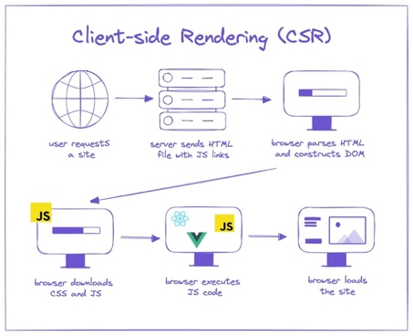
- Speed optimizations in CSR often require costly block rewrites, where each component must be manually adapted to support server-side rendering — disrupting existing structure and increasing development effort.
- Leading to explore a compiler-based approach instead.

Why Client-Side Rendering Fails for Performance-Critical, SEO-Dependent Web Apps

1. Slower Initial Load

What happens in Milo's Client-Side Rendering:
- Browser receives minimal but meaningful HTML (e.g., photoshop.plain.html) — block elements like <div class="marquee">, <section>, etc., are present, but lack behavior or enhanced layout.
- Triggers a cascade of network requests for block-specific JS, CSS, and data. Although Milo avoids large monolithic bundles, the block system loads scripts sequentially per section, increasing cumulative load time.
- JavaScript is parsed and executed block-by-block, enhancing each section in order .
- Even with static HTML present, many blocks rely on dynamic data via APIs — delaying full interactivity.
- Only after all of this is the page fully interactive with animations, hover effects, and layout finalization.

Why this is problematic:
- The user sees a blank screen longer than expected.
- Interactivity is delayed, especially on first section or global nav.
- Performance metrics such as:
  - FCP (First Contentful Paint)
  - LCP (Largest Contentful Paint)
  - TTI (Time to Interactive) are negatively impacted.

Real-world impact:

On slow connections or low-end devices, LCP/FCP can exceed 4s, leading to a "Poor" rating in Core Web Vitals, ultimately hurting SEO and user experience.

2. SEO Limitations
What happens in Milo's Client-Side Rendering:
- The server responds with minimal but meaningful HTML (e.g., photoshop.plain.html) containing structural elements and block wrappers.
- Main content and layout enhancements load only after JavaScript execution.
Why this is problematic for SEO:
- Many search engine crawlers (especially those other than Google) do not reliably execute JavaScript or wait for full page enhancement.
- As a result:
  - Critical text content may never appear to the bot.
  - Pages risk being indexed without headings, descriptions, or product information
- Impact:
Pages depending on Milo's default CSR can suffer from incomplete indexing, affecting pages that rely heavily on organic traffic. This can lower search rankings despite having good visual content for users.

3. P75 Effect – Even Fast Users Suffer
What P75 means:
• Core Web Vitals measure at the 75th percentile, not average.
• This means: 25% of page loads are slow — for example, LCP ≥ 3.9s.
Now imagine a user visits 5 pages on your site:
- What’s the probability all 5 pages are fast?
→ 0.75^5 = 0.237 → Only 23.7%
- So, what’s the chance they hit at least one slow page?
→ 1 - 0.237 = 0.763 → 76.3%
Implication:
Even if just 1 in 4 pages is slow,
Most users (76.3%) will hit a bad page when browsing just 5 pages.
Why it matters:
• Users remember the slowest page, not the fastest.
• Slow pages lead to frustration, loss of trust, and higher bounce — even for fast devices on fast networks.
• In multi-page apps like Milo, this compounds quickly.

Adobe’s Real-World Results:
- LCP dropped from 7.2s → 3.4s
- TTI dropped from 33.3s → 4.5s
- Mobile engagement rose 35%, bounce rate fell 6%, and time on page rose 21%
- A 2022 survey shows: 1 in 2 users abandon sites that take over 6s to load.
Summary:
• 25% of pages slow → sounds okay in isolation
• But in a 5-page session → 76% chance of poor experience
• So even "fast" users are not safe from bad UX

4. Inefficient JavaScript Usage
What CSR does:
- Milo triggers multiple cascading network requests per block instead of shipping a single large JS bundle.
- Client must:
  - Download the JS,
  - Parse it,
  - Execute it before showing anything meaningful.
Why it's bad:
- Increases:
  - Time to Interactive (TTI) – when page becomes usable.
  - Total Blocking Time (TBT) – JS blocks the main thread.
  - Interaction to Next Paint (INP)- Total time from interaction ➝ to visible UI update (breaching the 200ms threshold).
- JS parsing overwhelms CPU, Page becomes janky or unresponsive.

5. Wasted Execution Time:
CSR doesn’t just depend on JS execution — but a full orchestration chain, including:
- Logic to decide which components or routes to load,
- Time to load external resources like styles/images,
- Time to paint the DOM after layout & hydration.
Breakdown:
• 2–3s: JS file discovery + parsing per block,
• 3–4s: Block-specific data fetches
• 2–3s: DOM updates, font/image loads, and interactivity setup.
Result: 10–15s before the user can meaningfully use the page. That’s huge friction, especially on first-time visits.

6. LCP is delayed by Design
In CSR, LCP (Largest Contentful Paint) — the biggest visual element — only shows up after:
- The JS is fully executed,
- Data is fetched,
- DOM structure evolves as blocks are decorated dynamically,
- Styles are applied,
- Images load and paint.
This makes LCP timing unpredictable and non-deterministic, which:
- Hurts Core Web Vitals scores,
- Makes the page feel "slow" to users,
- Results in inconsistent rendering across users/devices.

7. Harder to optimize the Critical Rendering Path
In CSR:
- You can’t predefine the rendering priority of content.
- The browser must wait for JS to execute before it knows:
  - What elements to paint,
  - What to lazy-load,
  - What to defer.
Why this is problematic:
- You lose control of the critical rendering path, unlike SSR/SSG where:
  - HTML is delivered fully formed,
  - CSS and images can be prioritized,
  - Render-blocking elements are minimized.
Conclusion: Browser is “blind” until JS hydration finishes — making fine-grained performance tuning very difficult.
 | Good | Needs Improvement
FCP | [0, 1800ms] | (1800ms, 3000ms]
LCP | [0, 2500ms] | (2500ms, 4000ms]
CLS | [0, 0.1] | (0.1, 0.25]
INP | [0, 200ms] | (200ms, 500ms]
TTFB (experimental) | [0, , 800ms] | (800ms, 1800ms]

OBJECTIVES
- Improve page load speed and SEO by pre-rendering HTML via SSR.
- Reduce unnecessary JavaScript execution on non-interactive components.
- Enable fine-grained hydration only where interactivity is needed.
- Maintain compatibility with existing Milo blocks and workflows.

PLAN
Server-Rendered HTML
Interactive Page

Selective
JS Logic

1. Static Site Generation(SSG) with Artemis
Static Site Generation (SSG) means HTML is rendered once at build time, not during each user request.
Artemis, Milo’s headless rendering engine, uses Puppeteer to output fully populated HTML pages ahead of time, which are served instantly on request.
Functionality
Browser requests URL Server returns fully rendered static HTML
Browser displays meaningful content JS is deferred for interactivity of dynamic blocks
Data is prefetched/injected during build Page was visible from the start

WHY Static Site Generation?
• Fixing Slower Initial Loads (FCP/LCP)
→ SSG delivers fully rendered HTML upfront, reducing time to first paint and making content visible instantly.
• Improving SEO Discoverability
Static HTML is crawlable without JavaScript, improving search indexing.
• Reducing Execution Cost
→ Rendering and data-fetching happen during build time, so client devices are spared the overhead of heavy JavaScript execution.
• Stabilizing LCP (Making It Deterministic)
→ Since content is already in the HTML, large visual elements like hero banners load predictably, improving Core Web Vitals.
• Enabling Fine-Grained Control Over Rendering Path
→ Developers can control the order and priority of what loads first, optimizing both perceived performance and interactivity.

2. Modular Hydration
Only hydrate what’s interactive. Let static content stay static.
Why Modular Hydration?
• Loading JS for every block is wasteful if not all blocks are interactive.
• Static content shouldn't block page interactivity.
• Reduces JavaScript bundle size and parsing cost
• Accelerates TTI (Time to Interactive)
• Makes hydration lightweight and scoped
• Developers annotate interactive elements with @hydrate
• A lightweight runtime parses and hydrates only those blocks
• Leverages Babel Parser to extract hydration-annotated logic at build time

3. Headless Rendering using Puppeteer
- Why:
Simulates browser behavior in a server environment for accurate rendering.
- What It Solves:
  - Ensures full layout and visual correctness in the rendered HTML.
  - Enables reuse of rendered output across caching layers.
Artemis uses Puppeteer to render pages in a headless Chromium instance

4. Babel Parsing & Compilation
Babel plays a crucial role in our build process — not just for transpiling modern JavaScript into browser-compatible code, but also for parsing, extracting, and transforming logic blocks marked for hydration (e.g., @hydrate).
Objective:
Ensure that all relevant code and dependencies required by @hydrate blocks are:
- Detected and isolated from the original file.
- Resolved recursively (including imports, helper functions, variables).
- Transformed into a standalone, minimal JS file that can run without runtime errors.

Process Flow

1. Tokenization → AST Generation
Each JavaScript block file first goes through:
- Tokenization: Breaking code into tokens like identifiers, keywords, etc.
- Parsing via Babel: Tokens are converted into an Abstract Syntax Tree (AST) — a structured representation of the code, ideal for analysis and transformation.

2. AST Traversal & Dependency Resolution
We use @babel/traverse to walk through the AST. The goal is to identify and extract all necessary logic that a hydrate block depends on.

A. Class-Level Dependency Resolution
- Tracks calls like this.method() inside classes.
- For each method/property used:
  - Finds its definition (ClassMethod or ClassProperty node).
  - Extracts inner references:
    - Other methods it calls (this.otherMethod())
    - Identifiers/variables it uses.
// Recursive loop until all dependencies resolved
do {
// Traverse AST: extract methods, track new ones
} while (new classDependencies are found);
Output:
extractedClassMethods – a set of AST nodes representing class methods needed for hydration.

B. General Dependency Resolution
- Covers global functions and variables outside of classes.
- Looks for:
  - Function declarations: function helper() {...}
  - Top-level variable-based functions: const helper = () => {...}
// Recursive loop for resolving non-class dependencies
do {
// Traverse AST: extract functions, gather new dependencies
} while (new global dependencies are found);
Output: extractedNodes – contains AST nodes for helper functions and top-level variables.

3. Import Extraction
After collecting all required identifiers:
- Traverse the AST for ImportDeclaration nodes.
- Retain only those imports whose specifiers are actually used.
- Rewrite the import paths if necessary (e.g., from relative ./ to known aliases like ../global-navigation/...).
if (importedIdentifier in dependencies) {
importNodes.add(path.node);
}
Output: importNodes – ensures hydrated file includes all valid import statements.

4. Code Generation
With all required AST nodes (methods, functions, imports) collected:
- Babel’s code generator (@babel/generator) is used to convert the modified AST back into clean JavaScript code.
- This forms the final hydrated JS file.

5. Linking to Page (Dynamic Hydration)
- Hydrated file is dynamically linked to the DOM using hydration IDs.
- A corresponding JSON script assigns hydration tasks to components.

By using Babel's parser and AST traversal:
- We isolate only the interactive logic needed for hydration.
- Remove unused code, making the build lean.
- Ensure zero runtime errors by preserving dependencies.
- Output clean, self-contained JavaScript files ready for dynamic hydration.

IMPLEMENTATION
- Detect Block Entry Points
Identify Milo blocks under libs/blocks/ that may require hydration logic.
- Extract Hydration Annotations
Parse @hydrate and @hydrate.class markers from source files using extract-all.js
- Transform Hydration Code
Convert extracted @hydrate annotations into explicit window.__hydrate__ task registrations using transform-hydration.js, ensuring each task has a unique ID and is ready for runtime execution.
- Configure Components
Copy original blocks and inject hydration-specific code and runtime hooks into the duplicated files via build.js.
- Prepare Hydration Runtime
Initialize hydration-runtime.js, which maintains a task registry (window.__hydrate__) for all extracted hydration handlers.
- Server-Side Render (SSR)
Use index.js with Puppeteer to render the page in a headless browser, outputting fully formed HTML and hydration metadata.
- Send HTML Response
Serve the rendered HTML to the browser, including hydration placeholders and a script to evaluate window.__hydrate__.
- Match DOM & Hydration Tasks
On client load, hydration runtime matches elementId from the DOM with taskId in the hydration map.
- Attach Interactivity or Skip
If both task and element match, bind behavior (e.g., event listeners); if not, skip silently, preserving performance.
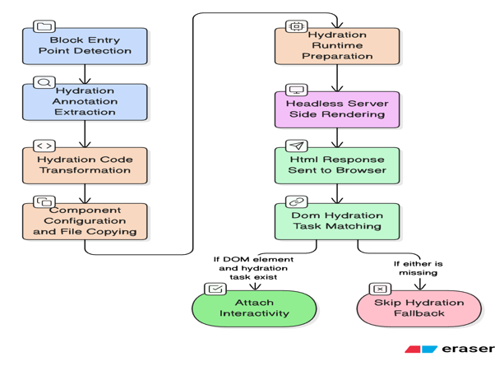

TECHNOLOGIES USED :
Node.js | Runtime environment for executing server-side scripts including build, extraction, and rendering tasks.
Puppeteer | Headless browser used by Artemis to perform server-side rendering and simulate DOM for HTML snapshotting.
Babel Parser | JavaScript parser used to extract and analyze hydration annotations (@hydrate) from source code.
Artemis | Internal SSR engine at Adobe used to generate pre-rendered HTML from Milo blocks.
JavaScript (ES6+) | Core language used for both block logic and hydration annotations.
HTML/CSS | Structural and styling languages for blocks and decorated content.
Milo Framework | Adobe’s in-house content-first framework based on modular block architecture.
Git & GitHub | Version control and collaboration for project tracking and code integration.

SCHEDULE - 10 Week Implementation Plan
Week | Milestones & Activities | Status
Week 1 | • Detection of Milo block entry points in libs/blocks/;  • Extraction of @hydrate and @hydrate.class annotations using extract-all.js | Done ✅
Week 2 | • Transformation of extracted hydration logic via transform-hydration.js;  • Setup of component-level configuration and file duplication through build.js | Done ✅
Week 3 | • Development of hydration-runtime.js to manage window.__hydrate__;  • Integration of Artemis SSR engine and Puppeteer setup | Done ✅
Week 4 | • Rendering of static HTML using headless browser (Puppeteer);  • DOM element and hydration task ID matching on client-side load; | Done ✅
Week 5 | • Hydration of standalone JS blocks (accordion, tabs, editorial card, etc.);  • Fallback-safe: Skipping hydration if either the DOM or task is missing | Done ✅
Week 6 | • Hydration of standalone JS blocks (modal,editorial card, aside,hero-marquee etc.);  • Selective script injection and runtime tracking | Done ✅
Week 7 | • Inline script injection for global navigation interactivity  • Config declaration for implementing unav functionality  •Documentation | Done ✅
Week 8 | • Handling class-based blocks (global navigation, footer) hydration;  • Merch card hydration | Done✅
Week 9 | • Performance benchmarking (LCP, CLS, TTI, TBT) using Lighthouse/Web Vitals; | Done✅
Week 10 | • Final Demo and post-implementation review | Pending

Development Roadblocks

1. Population of data-feds for Class Hydration
- Issue:
Class-based hydration requires the presence of a data-feds attribute that maps hydration task IDs.
Hypothesis:
This attribute was not generated dynamically and had to be manually added.
- Resolution:
To enable automated class-based hydration, we implemented the following:
  - For classes like feds-* used in the Gnav header:
    - A dynamic data-hydrate-id is injected into the DOM.
    - This ID is used to populate the data-feds mapping.
    - The attribute is attached directly to the relevant DOM node (e.g., <header>).
- The hydration engine invokes customParseWithDomAndClasses.
- It detects elements with data-feds and looks up the associated constructor:
    - DEBUG: Using CLASS_REGISTRY: ObjectGnav: {type: ƒ, inh: ƒ}
- The type "Gnav" resolves to the custom class GnavHydrate.
- The constructor is instantiated with context:
    - new Gnav({ content, block, newMobileNav: true })

2. HTML Attributes Conflicting with Client-Side Interactivity
- Issue:
When pages were pre-rendered using Puppeteer, attributes like data-mouseEvent="true" were already set in the final HTML. This bypassed JavaScript condition checks, preventing interactivity from being re-applied (e.g., in Editorial Card’s hover-play functionality).
- Resolution:
Removed or reset the interfering attributes from the static HTML output to allow client-side JS to re-evaluate and re-bind the appropriate event listeners.

3. Video Interactivity Loss Due to Missing Anchor Decoration
- Issue:
In blocks like hero-marquee and aside, interactivity depends on <a> tags being transformed into <video> elements via decorateAnchor() and applyAccessibilityEvents(). However, Puppeteer rendered HTML already had <video>, skipping the decoration logic.
- Resolution:
  - Invoked applyAccessibilityEvents() post-render to manually bind the required video event handlers and restore expected interactivity behavior.
  - Added hydration annotations to decorate.js decorate-hydrate.js ,
No need to invoke the applyAccessibilityEvents() post-render , handled by decorate-hydrate.js

4. Poor LCP Performance Despite SSR
- Issue:
The LCP on the SSR-rendered page was worse than on the live Photoshop production page — even though LCP reduction was the primary goal.
An image with multiple viewport variants took over 5 seconds to load in the headless version, compared to ~3.7s on production.
- Analysis:
  - The headless browser loads all image variants in parallel, saturating available bandwidth — unlike the client which loads one responsive image.
  - JavaScript and CSS consume CPU but not much bandwidth; large images are the true bottleneck.
  - Design follows a client-side body-hiding model, making LCP worse under SSR.
- Resolution:
  - Identify the LCP image or video in the viewport and explicitly mark it.
  - Preload the LCP asset in the <head> to trigger earlier fetching
  - Ensure the LCP image size matches its actual rendered size to avoid overfetching.
  - For all non-LCP media (images, videos):
    - Strip src, srcset, and poster, and store them in data-* attributes.
    - Use an IntersectionObserver to lazily assign those attributes only when the element enters the viewport.
  - This prevents unnecessary bandwidth saturation during server-side rendering and ensures LCP-critical assets load first.

ARTEMIS V2 WORKING :
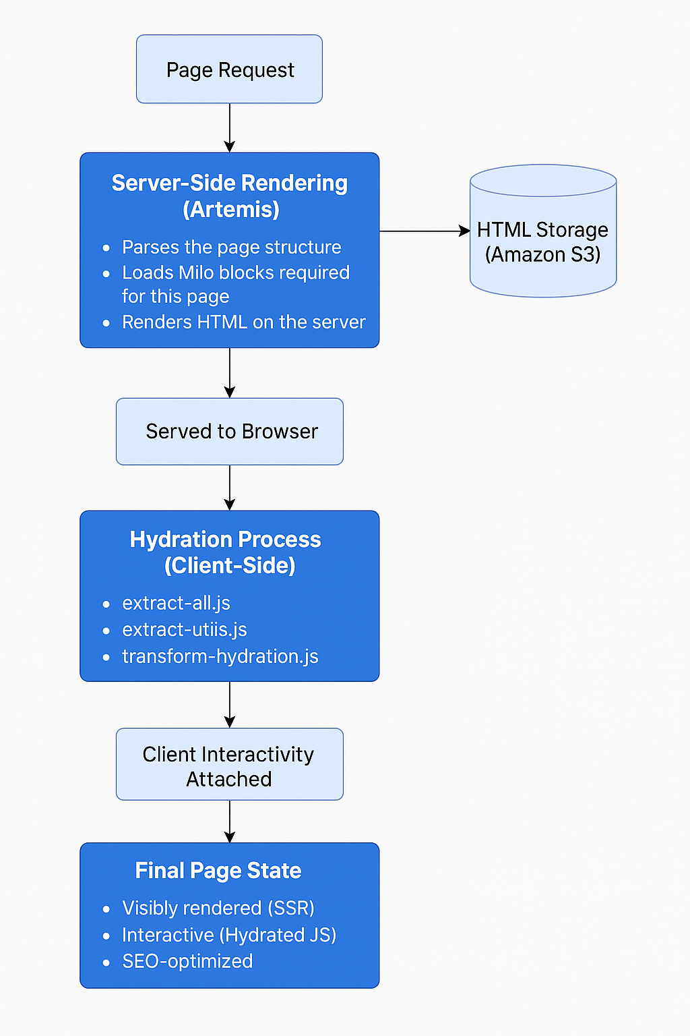
BEFORE AND AFTER PERFORMANCE COMPARISON :

CSR:
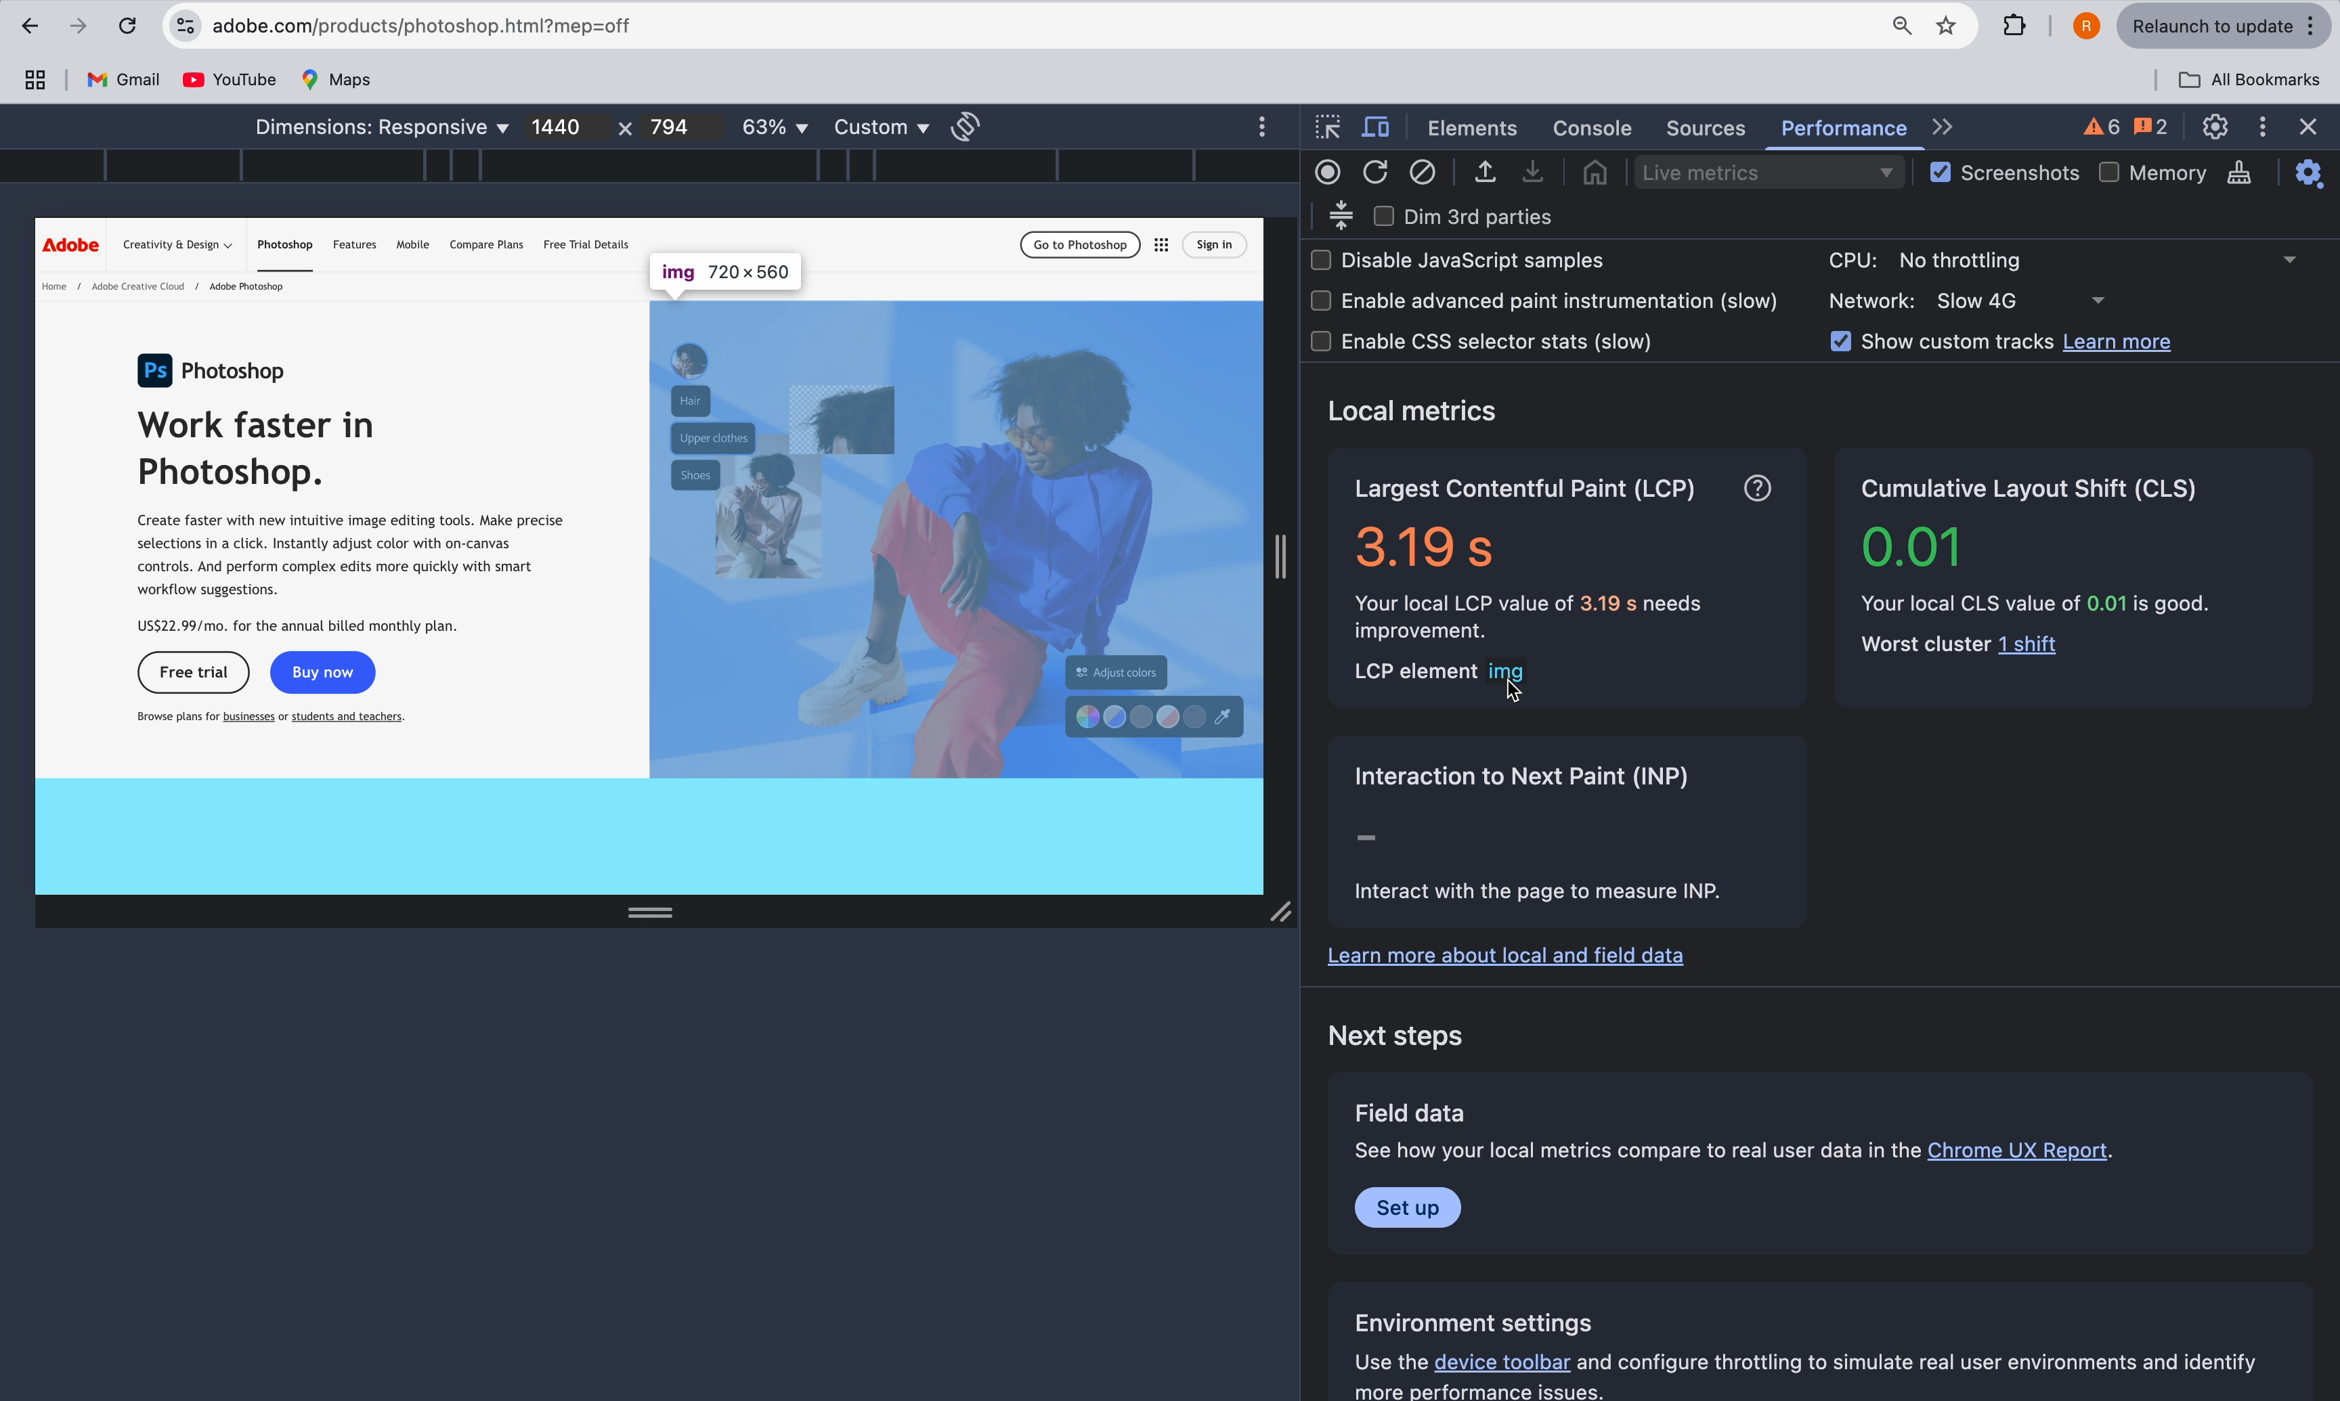

ARTEMIS:
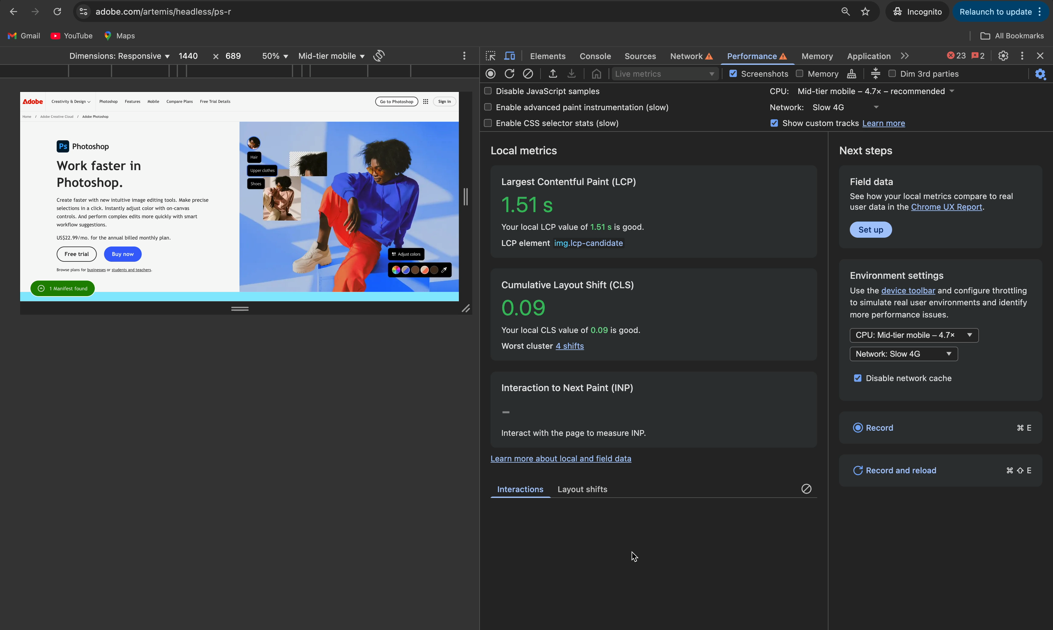

LEARNINGS:
1. Understanding the Limitations of Client-Side Rendering (CSR)
I learned that CSR alone isn't ideal for performance-critical or SEO-sensitive web pages. Even with fast JavaScript, users can experience slow first paint or broken interactivity. This helped me realize the importance of moving rendering logic earlier in the lifecycle — toward the server.

2. Applying Static Site Generation (SSG) with Puppeteer
I implemented SSG by rendering HTML using Puppeteer, allowing us to ship fully pre-rendered pages. This greatly improved page load performance and made the content visible without waiting for JavaScript to load. I now understand how SSG bridges the gap between SSR and CSR for hybrid sites.

3. Enabling Fine-Grained Modular Hydration
Using custom annotations like @hydrate and @hydrate.class, I built a modular hydration system that only hydrates what's necessary. This selective hydration reduced unnecessary JavaScript execution and improved runtime efficiency. It taught me how to apply progressive enhancement in a large-scale codebase.

4. Working with ASTs using Babel
I dove deep into Babel’s Abstract Syntax Trees (AST) to extract, analyze, and transform code at build time. This was my first real experience using ASTs for static code analysis, and it gave me a strong foundation in how modern frontend tools like compilers and linters work under the hood.

5. Building a Custom Hydration Runtime
I built the hydration-runtime.js module to dynamically map DOM nodes to their corresponding JavaScript constructors. I learned how to structure runtime registries and how to ensure safe execution when the DOM is pre-rendered. This made me appreciate the separation of concerns between static HTML and interactive behavior.

6. Using Headless Browsers for Server-Side Rendering
By using Puppeteer, I rendered pages in a headless browser to simulate real user output. I learned how to debug rendering issues, control page load events, and extract clean HTML. It showed me the power of automating rendering and testing in CI workflows.

7. Debugging Real-World SSR Challenges
I encountered and solved problems like missing data-feds attributes, conflicting HTML attributes from pre-rendering, and hydration logic being skipped. This taught me how to formulate hypotheses, validate them, and write maintainable fixes — a valuable real-world engineering skill.

8. Optimizing LCP with Lazy Asset Loading
I used IntersectionObserver to defer loading of non-critical images and videos. I learned how browser rendering works, how image loading affects LCP, and how to restructure HTML to prioritize performance. This had a noticeable impact on Core Web Vitals.

9. Working Within a Legacy Codebase
I didn’t rebuild the entire frontend stack — instead, I enhanced the existing Milo framework used internally. This helped me learn how to extend existing architecture without breaking it, and how to add modern capabilities incrementally and safely.

10. Embracing Project Ownership and Iterative Delivery
Following a structured roadmap across 10 weeks, I iterated on ideas, addressed feedback, and delivered working features. I became better at managing scope, communicating blockers, and aligning my work with end goals. It shaped my approach to product thinking and agile execution.

